Walton County School District
Title I SWP and TA Plan Amendment
School: Carver Middle School Year: 2015-2016
Principal: Dr. Dawn Spruill Date submitted: 1-20-16
Needs Assessment Data:
*All present EOG Data is before FAY consideration**
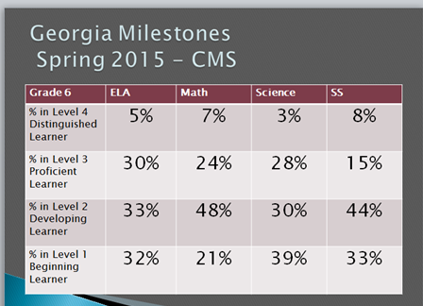
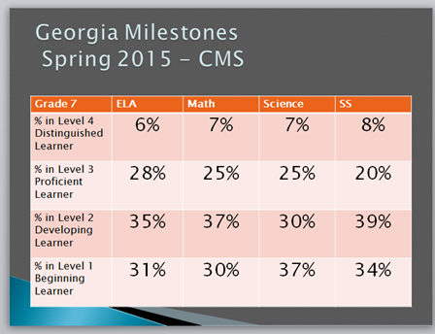

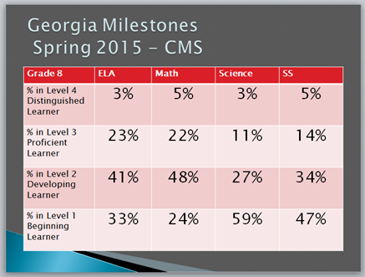

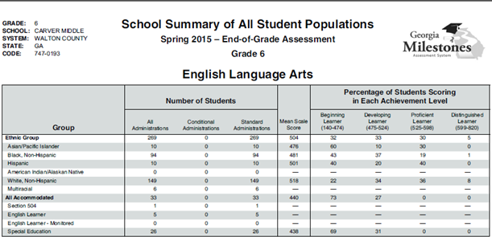

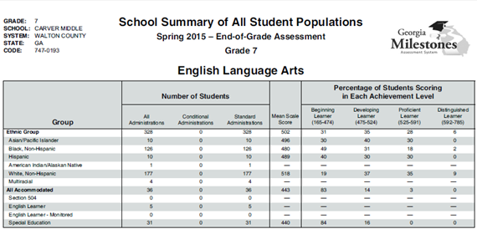

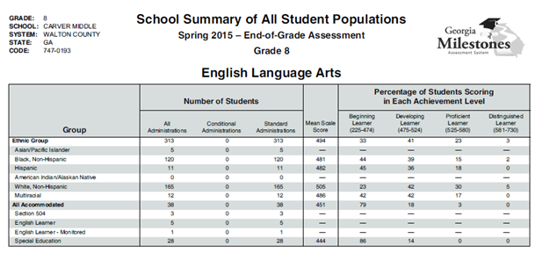

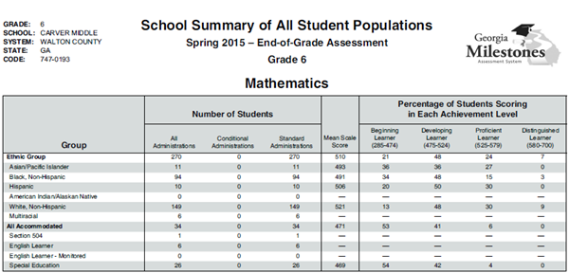

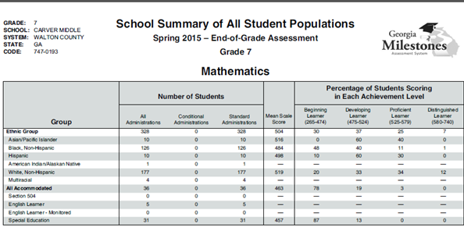

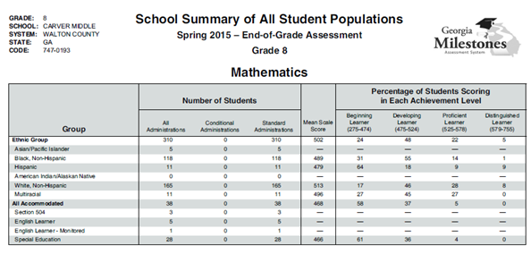

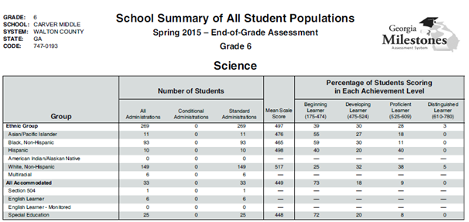

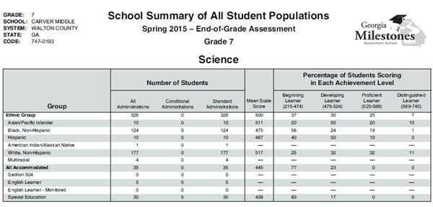

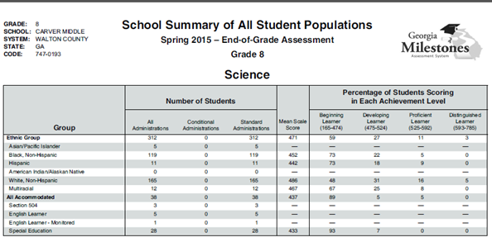

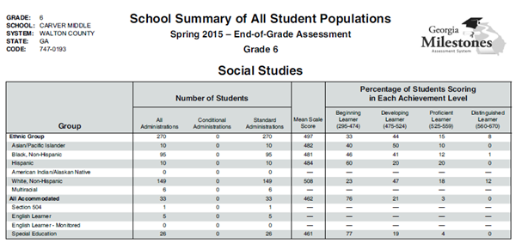
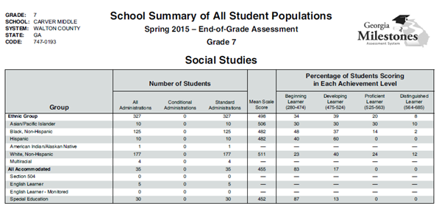
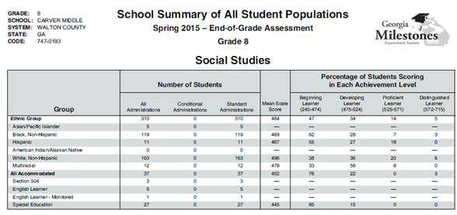

EOG School Summary of Primary Populations for All Grade Levels Combined

Subject Area | Beginning Learner %
Language Arts
· Asian/Pacific Islander | 30%
· Black, Non-Hispanic | 45%
· Hispanic | 42%
· White, Non-Hispanic | 21%
Math
· Asian/Pacific Islander | 25%
· Black, Non-Hispanic | 36%
· Hispanic | 38%
· White, Non-Hispanic | 17%
Science
· Asian/Pacific Islander | 38%
· Black, Non-Hispanic | 63%
· Hispanic | 51%
· White, Non-Hispanic | 33%
Social Studies
· Asian/Pacific Islander | 35%
· Black, Non-Hispanic | 52%
· Hispanic | 52%
· White, Non-Hispanic | 28%

Milestones Data Summary:
The Milestones and SLDS data shows that CMS has a significant achievement gap between white, non-Hispanic, students and black, non-Hispanic students, Hispanic students, Students With Disabilities, and Economically Disadvantaged students in ELA, Math, Science, and Social Studies.
Carver Middle School Discipline Data 14-15
Discipline Referrals Totals for 2014-2015
Carver Middle School | All Walton Co. Middle Schools | CMS Percent of Total Middle School Referrals
1,313 | 2,652 | 50%
Discipline Hearing/Waiver Totals for 2014-2015
Carver Middle School | All Walton Co. Schools | CMS Percent of Total WCPS Hearing/Waivers
43 | 161 | 62%

Teacher Perception Survey Results– Barriers to Student Achievement at CMS
1. Please rank the following reasons in order as they relate to the barriers of student progress/achievement at CMS. (1 the most / 5 the least)
__5_ Lack of Instructional Material
__4_ Lack of Academic Ability
__1_ Lack of Motivation / Unwilling to be Engaged
__3/2 Lack of Background Knowledge
__2/3 Behavior Issues
_____ Other _________________________________________________

2. What do you observe that inhibits students from learning in a CMS classroom setting? (Check the one that most applies.)
_8%_ Academic Ability
_80%_ Lack of Motivation / Unwilling to be Engaged
_12%_ Behavior
_____ Other _________________________________________________

3. What would impact student achievement at CMS the most? (Check the one that most applies.)
_9%_ More Student Background Knowledge
_48%_ More Student Motivation / Engagement
_18%_ Stronger Student Academic Ability
_15%_ More Cohesive Student Behaviors
_5%_ More Student Engagement
_5%_ Other ___Student Accountability_______

Behavior and Teacher Perception Data Summary:
The behavior data and student barrier perception data show that student behavior and students’ lack of motivation are significantly impacting student achievement at CMS.

** See additional CCRPI and Title 1 Parent Survey data in original SWP**

Strengths:
Milestones Developing, Proficient and Distinguished Math Score Percentages for all populations in all grade levels.
Milestones Writing Scores for all populations and all grade levels.
Needs:
· To decrease the beginning and developing learner percentages for the Hispanic students in all subject areas.
· To decrease the beginning and developing learner percentages for all subgroups in Science and Social Studies.
To increase the Proficient and Distinguished learner percentages for Science and Social Studies for all populations.
To decrease the beginning and developing learner percentages for Math for SWD, ED, Black, and non-Hispanic students.
· To decrease the achievement gap between Black, SWD, Hispanic, and ED students as they compare to white students in ELA, Science, and Social Studies.
· To increase the Student Growth Percentile in Reading, ELA, Math, and Social Studies.
· To continue to provide professional development in differentiated instruction for teachers.
To continue to supplement ELA, Science, and Social Studies departments with high interest and leveled reading materials.
Extended year program to remediate and preview for at risk students in science and Social Studies.

Targeted AREAS:
ELA
Math
Science
Social Studies
Differentiation
Motivation
Revised SMART Goals:
Measurable Language Arts Goal:
Carver Middle School’s 2015 Georgia Milestones End-Of-Grade Reading/ELA Assessment proficient and distinguished learner score percentage will increase by 3% for each grade level on the Carver Middle School 2016 Georgia Milestones End-Of-Grade Reading/ELA Assessment.
(6th - From 35% to 38%; 7th - From 34% to 37%; 8th From 26% to 29%)
Measurable Writing Goal:
The 6th Grade student pass rate of 45% on the winter 2015 Write Score Writing Assessment will increase to 48% on the winter 2016 Write Score Writing Assessment. The 7th Grade student pass rate of 51% on the winter 2015 Write Score Writing Assessment will increase to 54% on the winter 2016 Write Score Writing Assessment. The 8th Grade student pass rate of 83% on the winter 2015 Write Score Writing Assessment will increase to 86% on the winter 2016 Write Score Writing Assessment.

Measurable Math Goal:
Carver Middle School’s 2015 Georgia Milestones End-Of-Grade Math Assessment proficient and distinguished learner score percentage will increase by 3% for each grade level on the Carver Middle School 2016 Georgia Milestones End-Of-Grade Math Assessment.
(6th - From 33% to 34%; 7th - From 32% to 35%; 8th From 27% to 30%)
Measurable Science Goal:
Carver Middle School’s 2015 Georgia Milestones End-Of-Grade Science Assessment proficient and distinguished learner score percentage will increase by 3% for each grade level on the Carver Middle School 2016 Georgia Milestones End-Of-Grade Science Assessment.
(6th - From 31% to 34%; 7th - From 32% to 35%; 8th From 14% to 17%)
Measurable Social Studies Goal:
Carver Middle School’s 2015 Georgia Milestones End-Of-Grade Social Studies Assessment proficient and distinguished learner score percentage will increase by 3% for each grade level on the Carver Middle School 2016 Georgia Milestones End-Of-Grade Social Studies Assessment.
(6th - From 23% to 26%; 7th - From 28% to 31%; 8th From 19% to 22%)

Title I Carry Over Funds will be used to address:
Target/Goal | Description of items to be funded | Amount
ELA | 35 cases of copy paper x $30ea = $1050 (for printing and copying of supplemental Lexile leveled non-fiction science and social studies text to be used for differentiated instruction),  Ink cartridges and masters for printing and copying supplemental materials. 8 Gestetner cartridges @ $60ea, 4 Gestetner masters @ $102ea, 6 cartridges for various core classroom printers @ $125ea = $1,638. $30 heaphones for READ 180 @ $32ea = $960.  Supplemental equipment to be used by students in core content class. 2 LCD Projectors @ $900ea = $1,800  2 ELA T1 Tutors for a 4 day (4.0 hrs a day) extended year summer remediation program for 8th graders that fail ELA EOG - 2 teachers @ $25hr x 4 hrs a day x 4 days  Transportation to summer remedial tutoring for 8th grade | $1050  $2600  $1800  $800  $1288
Science | 2 Science T1 tutors for a 12 day (4.5 hrs a day) extended year summer tutor program for at risk students.  Transportation to summer program  90 Supplemental Science Periodicals | $2900  $4000  $390
Social Studies | 2 SS T1 tutors for a 12 day (4.5 hrs a day) extended year summer tutor program for at risk students.  Transportation to summer program  90 Supplemental SS Periodicals | $2900  $4000  $390
Differentiation/ Discipline/Motivation | M-Powering Choices Conference for 8th grade students to provide youth development and leadership services to increase academic achievement in all content areas as the 8th graders begin the transition phase to high-school.  5 cases of colored copy paper x $70ea = $350for consumable flyers, pamphlets, and brochures related to Parental Engagement and Title 1 School to Parent Communication. | $2500  $350
Math | 2 MA T1 Tutors for a 4 day (4.0 hrs a day) extended year summer remediation program for 8th graders that fail MA EOG - 2 teachers @ $25hr x 4 hrs a day x 4 days = $800.  Transportation to summer remedial tutoring for 8th grade  300 calculators to enrich differentiated math instruction. | $800  $1288  $1350

Submitted by: ________________________________ Principal ________________________ Date
Attach the following Documents:
- Carry Over Budget worksheet copy for Admin. Only.
- Flyer for Title I Planning Meeting to invite parent Participation/Data Review
- Agenda
- Sign in Sheets
- Minutes of meeting or Powerpoint presentation

